CADOGANS’ GROUSE BEATERS FIRST GWC – Narrated by Roddy Wilkie (2012)
Here we are again, embarking on another of Mad Dog McIntyre’s mid-summer madness dreamt up and agreed to in a flight of winter fancy.
This time around, the 2012 or third version of the Cadogans’ Grouse Beaters’ Team events, is the Great Wilderness Challenge - walking through the magnificent wilderness of Wester Ross.
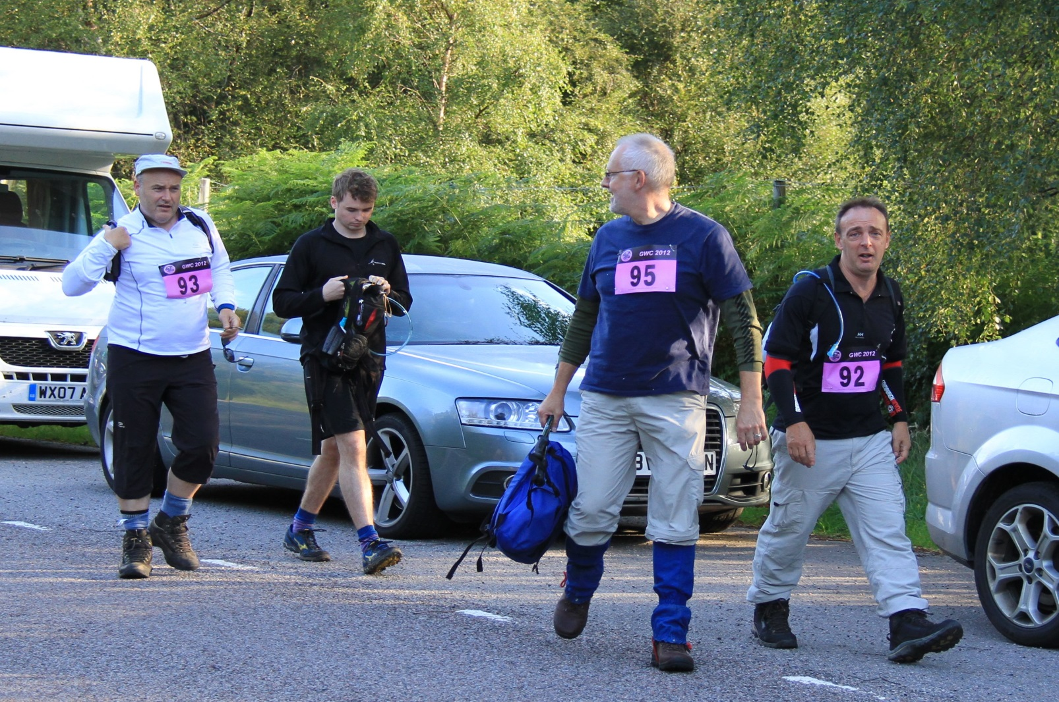
Check-in on Saturday morning is at an unearthly hour in Poolewe. The team comprises Roddy Wilkie,
Grouse Beaters David, Robbie, Roddy and Alan at Corrie Hallie start
David McIntyre, Alan Carruthers and David’s son Robbie McIntyre. Robbie is masquerading as Iain Hall who had to pull out a few weeks before. Iain’s way of getting out of the Challenge was to move house - one of the top half dozen of life’s most stressful events. Bit extreme, Iain! Next time forget the house move and just say you’re not up to it. We’ll be perfectly understanding!?! The first thing on arrival is check-in. The nice lady can’t find Iain Hall’s name on the sheet. “How do you spell Holme, dear?” Before Robbie starts spelling out H-O-L-M-E, we all dive in with “It’s Hall. H-A-L-L.” And the same for Iain. “It’s I-A-I-N.” “And he’s from Glasgow”, we add for good measure. She hesitates and then remarks pleasantly, “Are you his carers? It’s so nice of you to take him out for the day.” Oh dear, this is not a good start.
After check-in we are bussed to the start which is at Corrie Hallie, near Dundonnell, near Little Loch Broom, near … near … nowhere. Interesting name that Corrie Hallie. Or was it Hallie Corrie? Maybe Hallie Borrie?
The Great Wilderness Challenge - and it comes in several forms - the 7-mile version, the 13-mile version and the 25-mile version. So, of course, it’s the 25 miler for us. The only acknowledgement of tired and aching bodies (and that’s before we’ve even started) is we’re allowed to walk instead of run. Run? Yes, some are even madder than us. Run a marathon, but instead of on the level, it’s on rough rocky paths with a couple of steep ascents thrown in just for good measure.
However, it IS a lovely day. Sunshine! Dramatic skylines and skyscapes. The mountains are amazing … awesome ….. cool. And there’s a breeze (most of the time) to keep the millions and millions of wee biting tormentors known as midges that we can almost see peering out of the purple blooming heather waiting for their chance to attack.
Very quickly the serious business of putting one foot in front of the other starts to become the overriding business of the day. It’s not a gentle start. Off the bus that dropped us at Halle Borrie and it’s pretty much into the first climb.
The team quickly fragments. McIntyre Junior ambles towards the front of the pack with a nonchalance bordering on arrogance. Carruthers tucks in behind him, hoping to emulate the British Olympic cycling team by slipstreaming behind the leaders. Wilkie and McIntyre go for the Mo Farrah approach and settle into a steady if unimpressive pace but within sight of the leaders. We’ll catch up later. It’s round about this stage that you’re sussing out the opposition. I don’t mind being left for dust by him or her but I’m certainly not letting that decrepit old has-been beat me. Of course, the decrepit old has-been will probably turn out to be the current holder of the super-vets extreme fell runner’s world record.
It’s too hot in the sunshine and one of the day’s many clothing adjustments has to take place. If I’m to keep up with McIntyre Senior then it’ll have to be enacted on the hoof. T-shirt off. Thermal base layer off. Man-boobs on display (I would have claimed it as a wardrobe malfunction but nobody believed Janet Jackson so I doubt they would believe me). T-shirt back on. Don’t think anyone noticed. Stride hardly broken or pace slowed. That’s better.
Later on the pattern has developed. Endless mind-numbing miles with eyes fixed downwards to ensure the next step doesn’t miss the path or hit a rock or jar already aching soles and toes. Occasional brief glances upwards to take in the dramatic scenery. Every twenty minutes a cloud looms, the sky darkens and we’re drenched by a heavy but mercifully brief downpour. For some of us, this means a struggle to get waterproofs and bunnet on. Quickly followed by the reverse procedure when the rain passes and sun returns. Hard, extra work in addition to the walking stuff. Others of us (Mad Dog for one) seem immune to the drenching rain and carry on as if they are water-repellent. Makes keeping up more of a struggle than it need be. That, as well as the modest but noticeably weighty pack I’m carrying. Most seem to be carrying almost nothing. Hmmm. Note to self: Next time (if there is a next time) ignore all the dire warnings about refused entry if you do not have waterproofs, map, compass, whistle, first aid kit, spare boot laces, midge repellent, sun block, food, emergency food, water and change of shoes for fording the 2 rivers that are deep. I’m really pleased I also popped in the RSPB Pocket Guide to British Birds and binoculars. They weren’t put to much use as all bird life had been well scared off by the time I wandered through. Binoculars and bird book weren’t really required for the only wildlife spotted - a small frog and a hairy caterpillar.
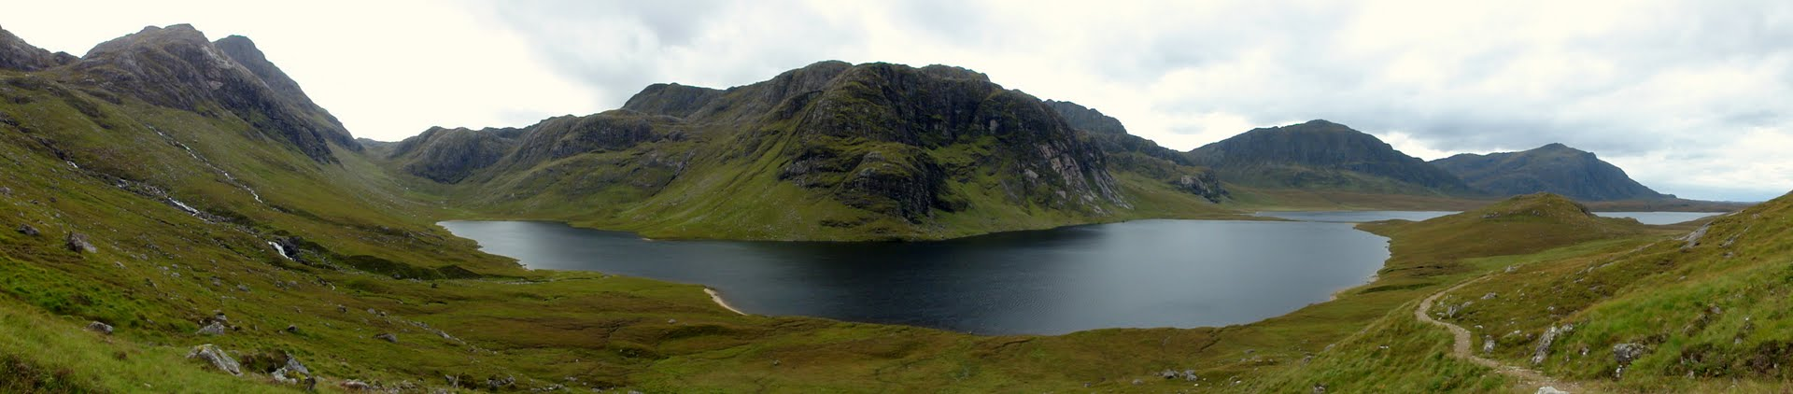
The views weren’t bad either!
The hardest part is undoubtedly the very steep climb up Gleann na Muice Beag to a height of 1,919 feet. That really gets the ticker working overtime. The summit and the next checkpoint is achieved. It’s Checkpoint 3, just plain water and orange coloured water (supposed to do you good).
I’m still slightly delirious after the gut wrenching climb to the top of Gleann na Muice Beag and starting the drop down into Carnmore beside Fionn Loch (Checkpoint 4, Mountain Rescue guys, excellent facilities and quality of service). Having got to the top, gasped for breath and had some water, I enquire of Mad Dog for how long we’re stopping. “You’ve had your stop”, he says and sets off. I blink and suddenly a gap is opening up between us. Memories of last year’s Rob Roy Challenge and the false promise of “All for one and one for all!” return. He’s trying to get away from me again. We’ll see about that.
I buckle down but despite my best efforts a mile or so further on and a few hundred yards have opened up between us. How did that happen?
Strange things are going on. I’m trying hard. Concentrating on the hard work of putting one foot in front of the other. My mind’s drifting. All I can see is Mad Dog’s gently swaying posterior disappearing in the distance. The name of the start point, Corrie Halle, is in my head. Halle Corrie. Halle Borrie. Somehow Corrie Halle morphs into Halle Berry, the Bond Girl from Die Another Day and allows me to drift from the unpleasant McIntyre posterior into more pleasant orange-bikini images.
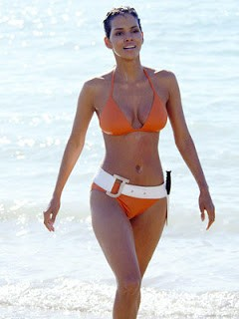 | 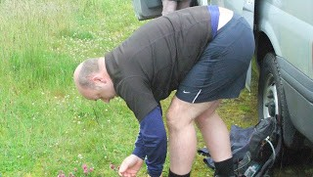
David McIntyre | Halle Berry
I awake, as suddenly people are passing me. Not just one. Many. Have I started going backwards? No, it’s OK. It’s the runners. They started hours after us walkers and suddenly they are breezing past with hardly a care in the world. 2 guys pass and then the first girl. Soon they are out of sight and I can resume my solitary Bond Girl musings.
Suddenly. What’s that I can see ahead? The rhythm of the McIntyre posterior swaying seems to have increased from gentle swing tempo to furious rock tempo. It can’t be. Yes, it is. Mad Dog’s running! I must be hallucinating. Look again. Screw up eyes. Peer. Glasses off. Rub my eyes. Glasses on. He’s definitely running. He’s definitely trying to get away from me. Clydesdale horses can run (well only if they’re in a Pixar film called Brave) but McIntyre can’t run. What’s happening? Maybe we’re in a CGI film.
My word, things have plumbed new depths. This is desperate. In which case, if a Clydesdale horse can run then so can a thoroughbred. I amaze myself and reach the dizzying speed of 5.4 miles per hour (as confirmed by my satellite-tracking fancy-dan phone app later that evening) which overwhelms his feeble 3.7 mph downhill wind-assisted effort. 10 minutes later I have caught him up. Aaaahh! To the victor the spoils of ….. of …… another 12 miles to go. But at least I can fix my eyes on something other than the McIntyre rear. Checkpoint 6, HM Coastguard guys. Seems to be about a dozen of them. And they are definitely competing for the most hospitable checkpoint award. I make the mistake of saying to the Coastguard guys that the Mountain Rescue guys have drams on offer. “Come this way.” And in the back of their pick-up was what could only be described as a full bar. I desist from the proffered large whisky which is just as well as I think they’re mainly for the Coastguard guys and later on if there’s any left, for the mountain rescue guys when they come down off the hill.
It’s sunshine and downhill all the way for the final 5 or so miles and the finish line is in sight. McIntyre and Wilkie cross the line in a dependable but plodding 8¼ hours. Carruthers and McIntyre Junior are looking cool, calm and collected having finished ages before. Carruthers finished in 7½ hours (having been dragged along in the slipstream of, not Bradley Wiggins, but attractive young ladies who were keeping up a very fast pace for the last 10 miles or so. Maybe they were trying to get away from you, Alan!) and McIntyre Junior, justifying his early confidence, with a time of 5½ hours as the first walker across the line.
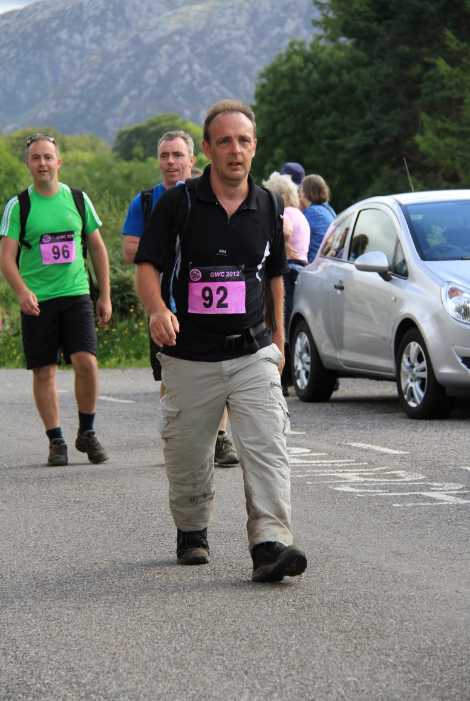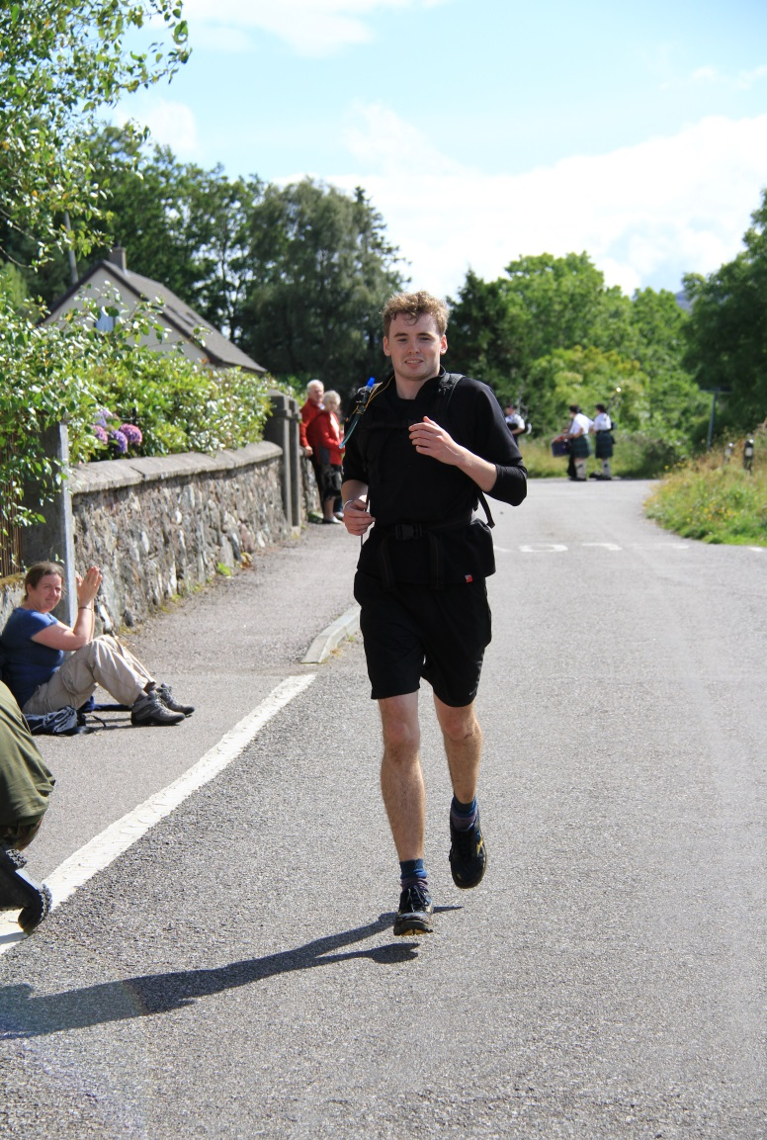
Alan Carruthers Robbie McIntyre
A celebratory bottle of Cava later and we’re staggering in the direction of The Pool House Hotel. We’re staggering not because of the alcohol but because the ancients amongst us have completely seized up in seconds after completing the 25 miles. We don’t go in but instead end up in the adjoining and suitably respectable Poolewe Community Hall where showers and sumptuous food await.
Boots off. Relax. Homemade soup. A few beers. A good night’s sleep awaits. Thank goodness it’s over. Apparently Mad Dog has already been heard to mention the Etape Caledonia (something about cycling a long way round two of Scotland’s bigger lochs) in May 2013 - but nobody’s listening . . . .
- Roddy Wilkie is the MD of Cadogans, a specialist engineering consultancy in Glasgow. Go to www.cadogans.com for further information

